### **Small Christmas Box for Cookies**

This small Christmas box can hold a few small cookies and candies. It is a perfect gift to give to a teacher, postman or neighbor to wish them a happy holiday.  
  
The box was made from 65 lb. card stock paper. The background paper is vellum which is a very thin transparent paper. As a alternative to cookies or candy, you can add a battery-operated candle inside for a pretty holiday decoration.

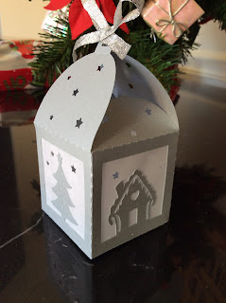

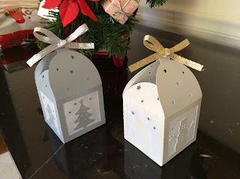

Happy Holidays!